This Week in Second Grade

5/11/15

**Math**

Chapter 13: *Customary Measurement of Length* will finish up this week. We have measured and compared using feet and inches. We will apply that knowledge to real-world problems. Expect a chapter review to come home Thursday with a test Friday.

**Reading**

*Amazing Animals* continues with the story “Ant.” “Ant is a nonfiction selection. During this reading students will think of questions to ask their classmates about the amazing world of ants.

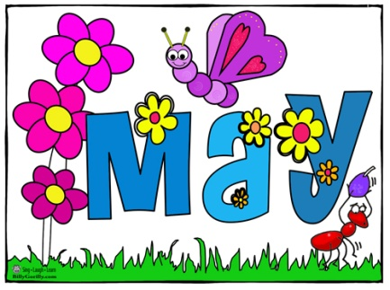

**Writing**

*Informational Writing: Personal Expertise* will be going on until the end of the year*.* We have started drafting some of our chapters. We have also studied many of the text features including table of contents, glossary, how-to, diagram, and a fun facts page!

**Science/Social Studies**

Science will be using scholastic news to look at bamboo and other plant features.

Social Studies is picking up with *Junior Achievement* which focuses on jobs and economics. A huge thank you to Jennifer Verlager for volunteering to teach JA in our classroom this year!

Things Found On The Classroom Website



[www.melissagorsegner.weebly.com](http://www.melissagorsegner.weebly.com)

* Math curriculum explanation and links to math website
* Spelling words and links to activities
* Pictures of our year
* Links for students and parents

Ms. Gorsegner’s 2nd Grade Gazette

C:\Documents and Settings\User\Local Settings\Temporary Internet Files\Content.IE5\I9CB8WY3\MC900442036[1].wmf

Last Book Orders

The last book orders of the year are coming home today. We will not have one in June with the short timing of things, so the May and June flyers are together. Consider looking for books that your child could read over the summer. Reading everyday is a perfect way to keep the brain working even when it’s on summer vacation!

This Thursday, Vowles is hosting Kindergarten Roundup. This is for children who plan to enter Kindergarten for the 2015-2016 school year. If you know of anyone that wants to attend, please have them contact the office for more information.



* Thursday, May 14th – Kindergarten Roundup at 6:00
* Friday, June 5th – Field Day

**Just a friendly reminder to please check agendas every day and initial it if you’ve read it.** I occasionally will put notes in there, but it is also important you check for homework. This is also a great way for you to communicate with me if needed!

Agendas

Remind

I am currently using Remind to send out reminder text messages to anyone interested. To sign up, send the message **@msgorse** to the number **810-344-6657**.