This Week in Second Grade

4/20/15

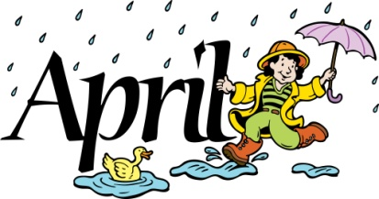

**Math**

We have started our next unit, Chapter 12: *Fractions.* During this unit we will look at halves, thirds, and fourths. In addition to identifying them, we will also be comparing them and adding like fractions.

**Reading**

*Amazing Animals* continues with the story “Officer Buckle and Gloria.” Officer Buckle’s safety speeches are more exciting than he’d planned. We will be monitoring our understanding as we read through this story.

**Writing**

*Informational Writing: Personal Expertise* will be going on until the end of the year*.* We have brainstormed ideas and are now working on our chapter ideas for the table of contents. This week we will also start drafting some of our chapters.

**Science/Social Studies**

Science will finish up with the water cycle. We will also look at our environment as we celebrate Earth Day.

Social Studies continue looking at “our community” of Mt. Pleasant. We will be working more on our mapping skills.

**TEMPERATURES ARE WARMING UP!**

**Please make sure your child has boots to school as our recess area can get muddy!**

Things Found On The Classroom Website



[www.melissagorsegner.weebly.com](http://www.melissagorsegner.weebly.com)

* Math curriculum explanation and links to math website
* Spelling words and links to activities
* Pictures of our year
* Links for students and parents

Ms. Gorsegner’s 2nd Grade Gazette

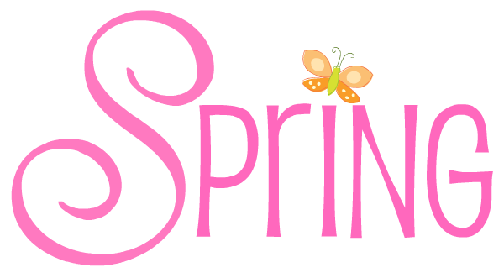C:\Documents and Settings\User\Local Settings\Temporary Internet Files\Content.IE5\I9CB8WY3\MC900442036[1].wmf

This week, our class will be taking the NWEA Math test. This assessment is online and adapts depending on how the student is doing. This is just one of the tools I use as a teacher to help understand your child’s needs. This is also the handout you received with report cards. Please help your child by making sure they get a good night’s sleep and a healthy breakfast!

NWEA

We are currently collecting box tops for a competition CMU is having. If we’re able to collect the most, we receive a big bonus of extra box tops. Each box top turned in counts for money towards our school. They are collecting all of the box tops this Friday. Thanks for collecting those for our school!

* April 27th – Vowles Talent Show
* Tuesday, April 21st – PTO Meeting
* Wednesday, April 22nd – Earth Day

Box Tops

**Just a friendly reminder to please check agendas every day and initial it if you’ve read it.** I occasionally will put notes in there, but it is also important you check for homework. This is also a great way for you to communicate with me if needed!

Agendas

Remind

I am currently using Remind to send out reminder text messages to anyone interested. To sign up, send the message **@msgorse** to the number **810-344-6657**.