This Week in Second Grade

3/23/15

**Math**

Chapter 11: *Money* started today. We will be identifying coins and dollars along with counting money. We will also find equivalency of coins to dollars. For example: 4 quarters equal one dollar. Encourage your child to use and identify money with you!

**Reading**

We will finish our theme: *Around Town* with the last story called ”Jamaica Louise James.” Jamaica Louise makes her community a happier place. While we read we will **evaluate** how well we like the story and characters.



**Writing**

The opinion writing unit is finishing up! We are in the final steps of publishing our pieces! This week will also be our opinion post-test.

**Science/Social Studies**

Science will be looking at mixtures and how they interact with each other. We will also start discussions on the water cycle.

Social Studies will be looking at “our community” of Mt. Pleasant. We will talk about the many businesses and the good or service they provide.

**TEMPERATURES ARE WARMING UP!**

**Please make sure your child has boots to school as our recess area can get muddy!**

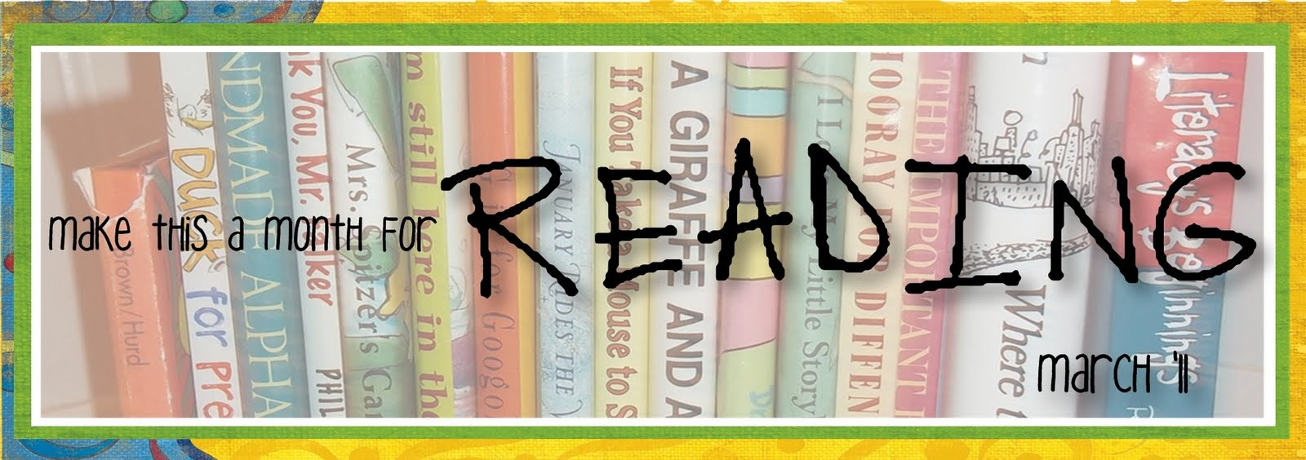

Things Found On The Classroom Website



[www.melissagorsegner.weebly.com](http://www.melissagorsegner.weebly.com)

* Math curriculum explanation and links to math website
* Spelling words and links to activities
* Pictures of our year
* Links for students and parents

Ms. Gorsegner’s 2nd Grade Gazette

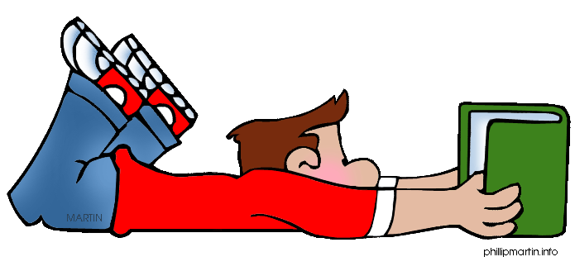C:\Documents and Settings\User\Local Settings\Temporary Internet Files\Content.IE5\I9CB8WY3\MC900442036[1].wmf

* Tuesday, March 24th: Book Fair Open
* Thursday, March 26th: Book Nic from 11:45-12:45
* Monday, March 30th: First day of SPRING BREAK!

Book Orders

Book orders are due Wednesday, March 25th. Please send in your order or do it online if you are interested!

The book fair is happening this week from Tuesday, March 24th through Thursday, March 26th. We did a preview as a class and your child has made a wish list.

Book-Nic is also taking place on Thursday, March 26th. Come from 11:45 – 12:45 to enjoy lunch with your child and share in a book or two!

Book Fair and Book-Nic

Many exciting things will be happening this month. Reference your calendar for every day. This week:

Monday – Write a letter

Tuesday – Joke Day

Wednesday – Wear Wacky clothes

Thursday – Book Nic

Friday – Teacher Read Around and BEST Celebration

March is Reading Month

**Just a friendly reminder to please check agendas every day and initial it if you’ve read it.** I occasionally will put notes in there, but it is also important you check for homework. This is also a great way for you to communicate with me if needed!

Agendas

Remind

I am currently using Remind to send out reminder text messages to anyone interested. To sign up, send the message **@msgorse** to the number **810-344-6657**.