This Week in Second Grade

3/16/15

**Math**

We will be finishing chapter 10: *Mental Math and Estimation.* Prepare for a review sheet to come home on Wednesday and the test of Thursday.

**Reading**

We will finish our theme: *Around Town* with the last story called ”Jamaica Louise James.” Jamaica Louise makes her community a happier place. While we read we will **evaluate** how well we like the story and characters.



**Writing**

The opinion writing unit is finishing up! We are in the final steps! We are working on revising and editing. They will also choose if they’d like to write or type their final draft.

**Science/Social Studies**

Science will be looking at mixtures and how they interact with each other. We will also start discussions on the water cycle.

Social Studies will be looking at “our community” of Mt. Pleasant. We will talk about the many businesses and the good or service they provide.

**TEMPERATURES ARE WARMING UP!**

**Please make sure your child has boots to school as our recess area can get muddy!**

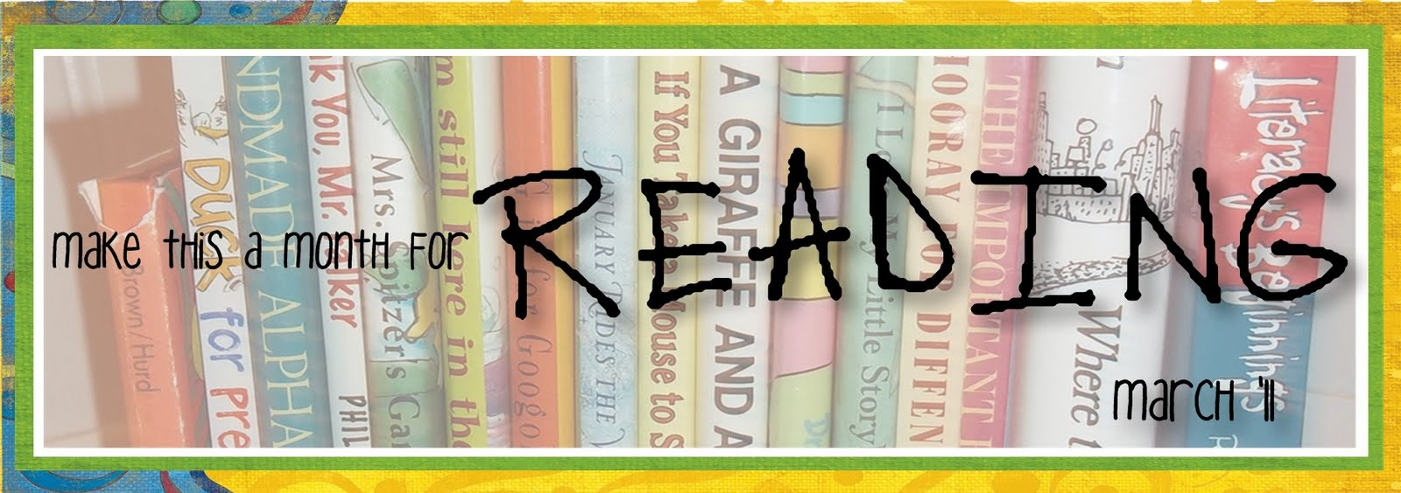

Things Found On The Classroom Website



[www.melissagorsegner.weebly.com](http://www.melissagorsegner.weebly.com)

* Math curriculum explanation and links to math website
* Spelling words and links to activities
* Pictures of our year
* Links for students and parents

Ms. Gorsegner’s 2nd Grade Gazette

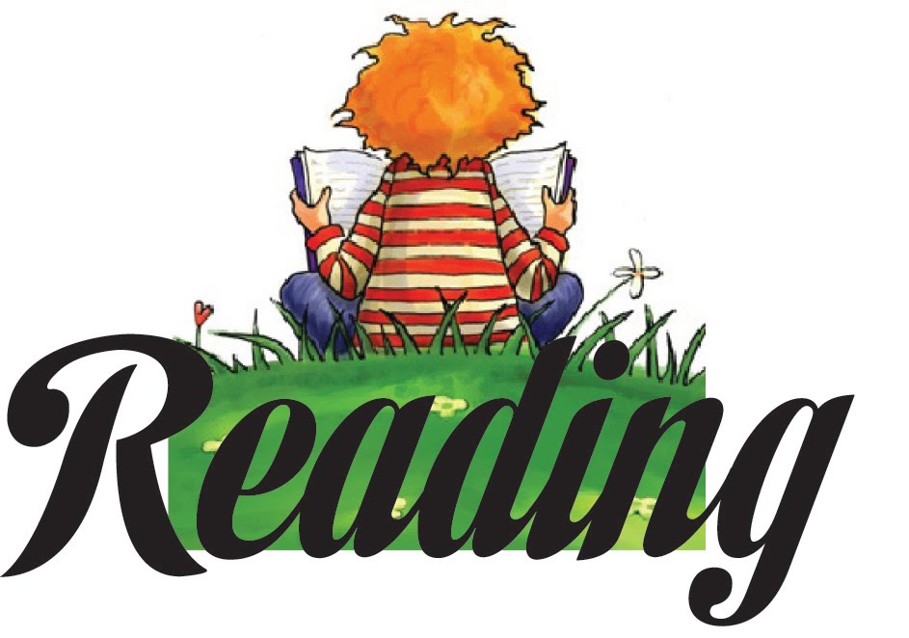C:\Documents and Settings\User\Local Settings\Temporary Internet Files\Content.IE5\I9CB8WY3\MC900442036[1].wmf

The book fair starts next week Tuesday, March 24th and continues through Thursday, March 26th. On Monday, our class with do a preview and your child will make a wish list.

Book-Nic is also taking place on Thursday, March 26th. Come from 11:45 – 12:45 to enjoy lunch with your child and share in a book or two!

Book Fair and Book-Nic

* Tuesday, March 17th: Spring Concert at MPHS at 6:30
* Friday, March 18th: Popcorn
* Tuesday, March 24th: Book Fair Open
* Thursday, March 26th: Book Nic from 11:45-12:45
* Monday, March 30th: First day of SPRING BREAK!

Many exciting things will be happening this month. Reference your calendar for every day. This week:

Monday – Create a treasure map

Tuesday – Wear green

Wednesday – Juicy Word Day

Thursday – Keep a poem in your pocket

Friday – Read books about traveling

March is Reading Month

March Book IT

Please send in February Book IT sheets this week.

March will not have a sheet coming home for Book IT. Because of March being reading month, we will be doing all our reading in class. If your child works hard in class, they will receive their March pizza certificate!

**Just a friendly reminder to please check agendas every day and initial it if you’ve read it.** I occasionally will put notes in there, but it is also important you check for homework. This is also a great way for you to communicate with me if needed!

Agendas

Remind

I am currently using Remind to send out reminder text messages to anyone interested. To sign up, send the message **@msgorse** to the number **810-344-6657**.