This Week in Second Grade

3/2/15

**Math**

We have started chapter 10: *Mental Math and Estimation.* We will work on strategies to doing mental math. I will always say, though, that we work on doing the problems in our head, but we can always check by using the strategies we know!

**Reading**

We will finish our theme: *Around Town* with the last story called ”Jamaica Louise James.” Jamaica Louise makes her community a happier place. While we read we will **evaluate** how well we like the story and characters.



C:\Users\Melissa\AppData\Local\Microsoft\Windows\Temporary Internet Files\Content.IE5\P80C9RR1\MC900446206[1].wmf

**Writing**

The opinion writing unit continues for us! We are in the final steps! This week we will focus on our conclusions and how to have a fantastic ending! After our conclusions we will be working on revising and editing. They will also choose if they’d like to write or type their final draft.

**Science/Social Studies**

Science will be looking at mixtures and how they interact with each other.

Social Studies will take a look at dental hygiene and the importance of staying healthy.

**TEMPERATURES ARE COLD!**

**Please make sure your child has warm clothes for recess!**

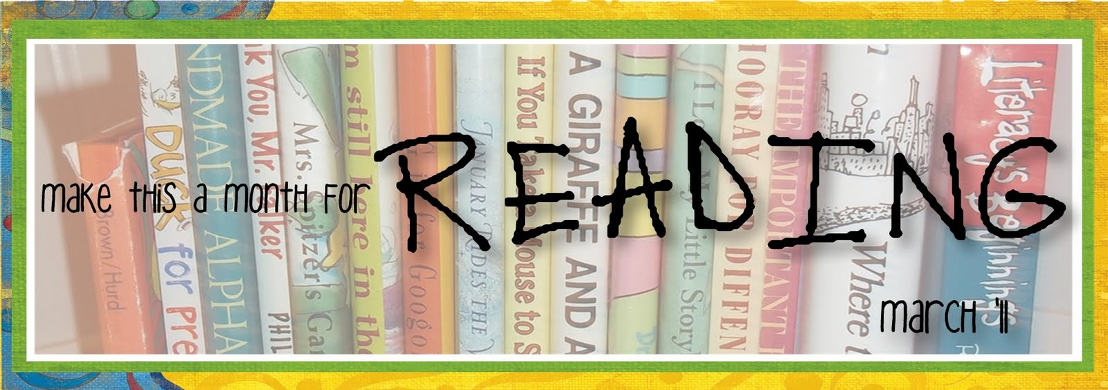

Things Found On The Classroom Website



[www.melissagorsegner.weebly.com](http://www.melissagorsegner.weebly.com)

* Math curriculum explanation and links to math website
* Spelling words and links to activities
* Pictures of our year
* Links for students and parents

Ms. Gorsegner’s 2nd Grade Gazette

C:\Documents and Settings\User\Local Settings\Temporary Internet Files\Content.IE5\I9CB8WY3\MC900442036[1].wmf

* Monday, March 2nd: Reading Month Begins!
* Friday, March 6th: Popcorn 50 cents
* Thursday, March 12th : ½ day of school - parent teacher conferences
* Friday, March 13th: No School – parent teacher conferences

Many exciting things will be happening this month. Reference your calendar for every day. This week:

Monday - Dr. Seuss’s Birthday

Tuesday - Bring your favorite book

Wednesday – Black out!

Thursday – Read a book about “under the sea

Friday – Read and Feed & wear RED

March is Reading Month

March Book IT

Please send in February Book IT sheets this week.

March will not have a sheet coming home for Book IT. Because of March being reading month, we will be doing all our reading in class. If your child works hard in class, they will receive their March pizza certificate!

Please remember to sign up for conferences if you haven’t yet. You are able to pick your own time slot by going to [www.ptcfast.com/reg1](http://www.ptcfast.com/reg1)

When there, you will need to enter the Entry Code: WH0174573. If you do not have internet access, you may use the computers in the lobby of the school or contact the office or me and we can schedule it for you.

Parent Teacher Conferences

**Just a friendly reminder to please check agendas every day and initial it if you’ve read it.** I occasionally will put notes in there, but it is also important you check for homework. This is also a great way for you to communicate with me if needed!

Agendas

Remind

I am currently using Remind to send out reminder text messages to anyone interested. To sign up, send the message **@msgorse** to the number **810-344-6657**.