2013

Dear Second Grade Families,

Welcome to second grade! I would like to introduce myself to you, I’m Melissa Gorsegner and you’re child’s second grade teacher. This is my second year at Vowles (last year I taught third grade) and my sixth year teaching.

I grew up with my parents and three older brothers in the small farming community of Pigeon, MI. I attended high school at Michigan Lutheran Seminary in Saginaw, MI and graduated from Alma College. I also am a recent Masters Graduate of Michigan State University. Month long education classes have allowed me to travel to Key West, New Zealand, and Ireland. I have previous working experience in multiple classrooms ranging from K – 8th grades. I enjoy playing and watching sports, playing piano, camping, watching movies, and visiting family. I love sharing stories of all my adventures, so feel free to ask!

I would like to take this opportunity as the year begins to stress the importance of your involvement and good communication. Being active in your child’s education directly affects his or her learning. I encourage you to daily ask what he or she did in class, help with schoolwork, and read with your child. I also like to have constant communication with you and your child. Please use the back side of this letter to help with communication that best works for you. You will find a few ways to make communication easier along with some classroom policies. Please feel free to contact me anytime you have a question or problem. I believe that together we can make this a successful year for your child.

Once again, I’m excited for a fun and positive year. I look forward to getting to know you and your child! Please keep me informed of any concerns, questions, or positive notes you may have, whether it is a phone call, e-mail, or note. I will work to do the same. Let’s have a great year!

Thank you,

Melissa Gorsegner

Contact Information
Vowles School: 989-775-2280
Vowles Website: tech.mtpleasant.k12.mi.us/vowles/
Mt. Pleasant Public Schools Website: tech.mtpleasant.k12.mi.us/mpps/
E-mail: mgorsegner@mpps.edzone.net

Website - melissagorsegner.weebly.com/
I have a website that I will be updating throughout the school year. Please reference it for basic information, newsletters, and resources for you and your child.
Please visit for your first homework assignment: filling out contact information.

Remind 101
Remind 101 is a useful tool in which I can send text messages to an entire group. I will only be sending messages for special events and quick reminders important to second grade. To subscribe to my text messages, text @msgorse in your message and send it to the number 810-545-4879.

Specials Schedule
Library books need to be at school Wednesday as they are returned first thing in the morning. Please also make sure that your child has proper athletic shoes for PE.
Monday – Computer Lab
Tuesday – Music and PE
Wednesday – Library
Thursday – Music and PE
Friday – Art

Rainbow Chart
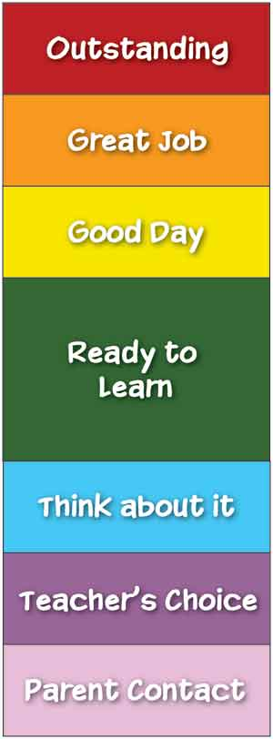
The rainbow chart is a technique I’ll be using in my classroom again this year. The clip chart consists of a chart that has been divided into levels. All of the children start the day on Ready to Learn. During the course of the day, the children move their clothespins up or down the chart, based on the behavioral choices they make. If they are making good choices, they can move their clothespin up a level at a time. Inappropriate behavior would cause them to move down a level. Since the children start in the middle of the chart, they have numerous opportunities to work their way up the chart. They also have an opportunity to turn inappropriate behavior around and clip back up. This really helps the children realize that they have to have self-control and be responsible for their actions and behavior if they want to be recognized for making good choices. Making it to the top of the chart is not easy, but it is definitely attainable. If students reach Outstanding, they will receive a reward of their choice.

